Department of Health “EatSmart@school.hk” Campaign Joyful Fruit & Veg Month 2026 Kindergartens & Child Care Centres
“Fruit and Vegetable Diary Card” Award Scheme Activity Guidelines

Each “Fruit and Vegetable Diary Card Award Scheme” activity kit contains
- Poster for Fruit and Vegetable Diary Card Award Scheme  (1 for each class)  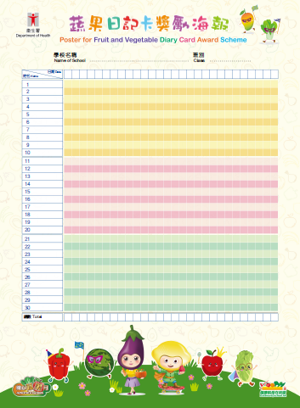 | - EatSmart Doggie Stamp        
- Fruit and Vegetable Diary Card  (1 for each pupil)  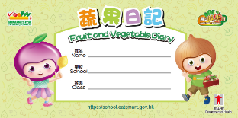  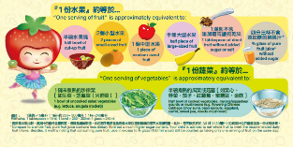  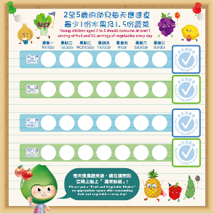 | - Fruit and Vegetable Diary Sticker  (1 for each pupil)  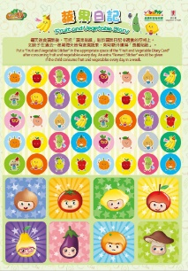

Activity details:
- The Department of Health (DH) specially designs a “Fruit and Vegetable Diary Card” Award Scheme for kindergartens & child care centres to enhance the awareness and habit of fruit and vegetables eating among children.
- The activity period lasts for not less than 28 days during which the participant schools can customise implementation dates at their disposal.
- Pupils should be distributed with Notice to Parents, “Fruit and Vegetable Diary Cards” and “Fruit and Vegetable Stickers”. Parents are encouraged to use the “Fruit and Vegetable Stickers” as reward for their children’s consumption of fruit and vegetables. The template of “Notice to Parents (Template)” can be downloaded from the Joyful Fruit & Veg Month webpage.
- Participant schools can post up the “Fruit and Vegetable Diary Card Award Scheme Posters” provided by DH in classrooms and check the “Fruit and Vegetable Diary Cards” once a week. If a pupil is found to have eaten fruit and vegetables for 7 days consecutively in the past week, he/she can be rewarded by putting stamps on the poster. For example, pupils who have eaten fruit and vegetables every day in the past week will receive 7 stamps, pupils who have eaten fruit and vegetables for 6 days will receive 6 stamps, and so on.

- Upon completion of the activity, the schools may collect the “Fruit and Vegetable Diary Card Award Scheme Posters” from various classes and then compute the overall statistical results using the following formula:

Total no. of stamps on all the posters in the school x 100% Total no. of pupils in the school x No. of activity days

x 100%
2000
100 x 28
= 71%
Example 2:
- Total no. of stamps on all posters in the school is 2 000
- Total no. of pupils is 100
- No. of activity weeks: 28 Statistical result:
x 100%
2800
100 x 28
= 100%
Example 1:
- Total no. of stamps on all posters in the school is 2 800
- Total no. of pupils is 100
- No. of activity days: 28 Statistical result:

- Please refer to the reply slip template below and email the statistical result to joyfulfruitnvegmonth@dh.gov.hk on or before 29 May 2026 (Friday).
- Schools that have statistical result of 75% or above will be recognised on the Joyful Fruit & Veg Month webpage by the DH. They may present certificates of appreciation (downloadable from the webpage) or other awards to pupils who met the activity requirement for encouragement.

Reply Slip Template
total: days
Statistics Period: From to
Statistical Result: %

Contact Person: Telephone:
District:
Name of Kindergarten & Child Care Centre:
Email Address: joyfulfruitnvegmonth@dh.gov.hk

Statistical Result of “Fruit and Vegetable Diary Card Award Scheme 2026”

